Layered Architecture
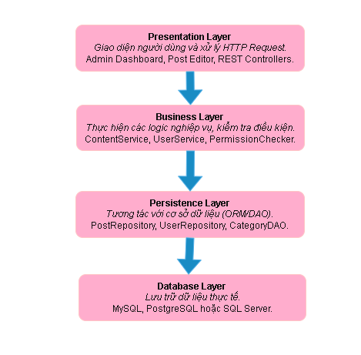
Microkernel Architecture

